**TUGAS PRAKTIKUM**

**PEMROGRAMAN BERORIENTASI OBJEK**

**KELAS A**

*“Tugas Pert – 08* Static Key*”*

Oleh:

Nama : Kevin Khozimah Zaki

NPM : 4523210057

Dosen:

Adi Wahyu Pribadi , S.Si., M.Kom

**S1-Teknik Informatika**

**Fakultas Teknik Universitas Pancasila**

**2024/2025**

Book.java

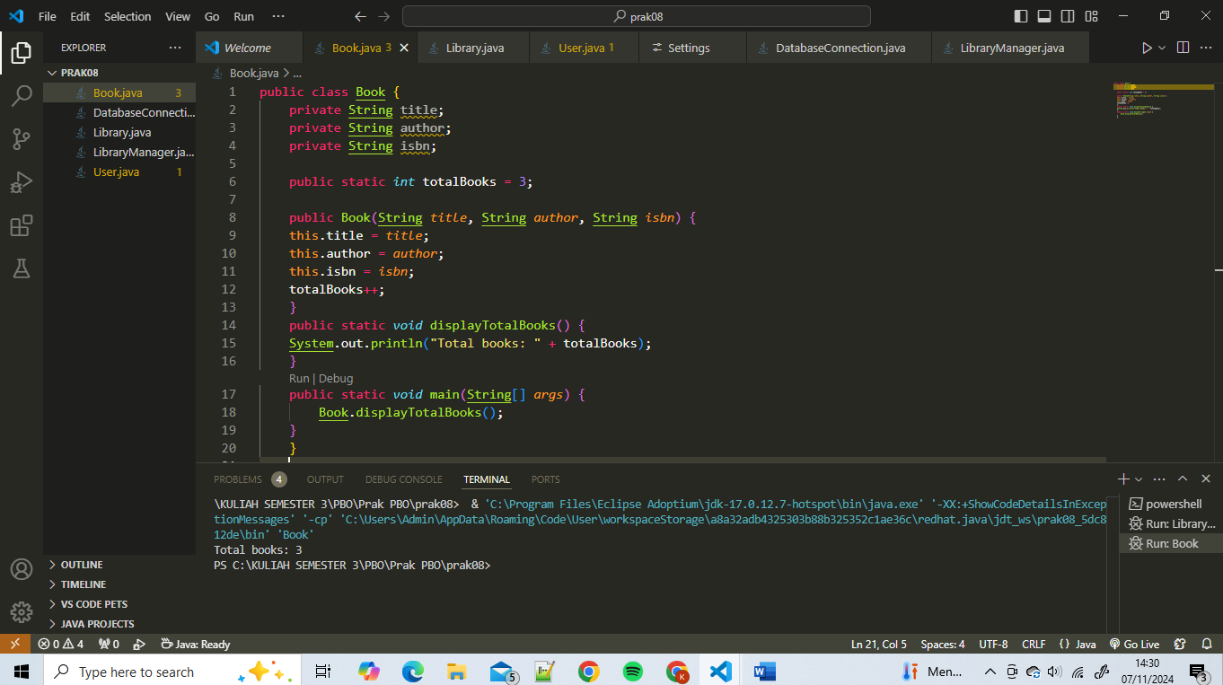

Library.java

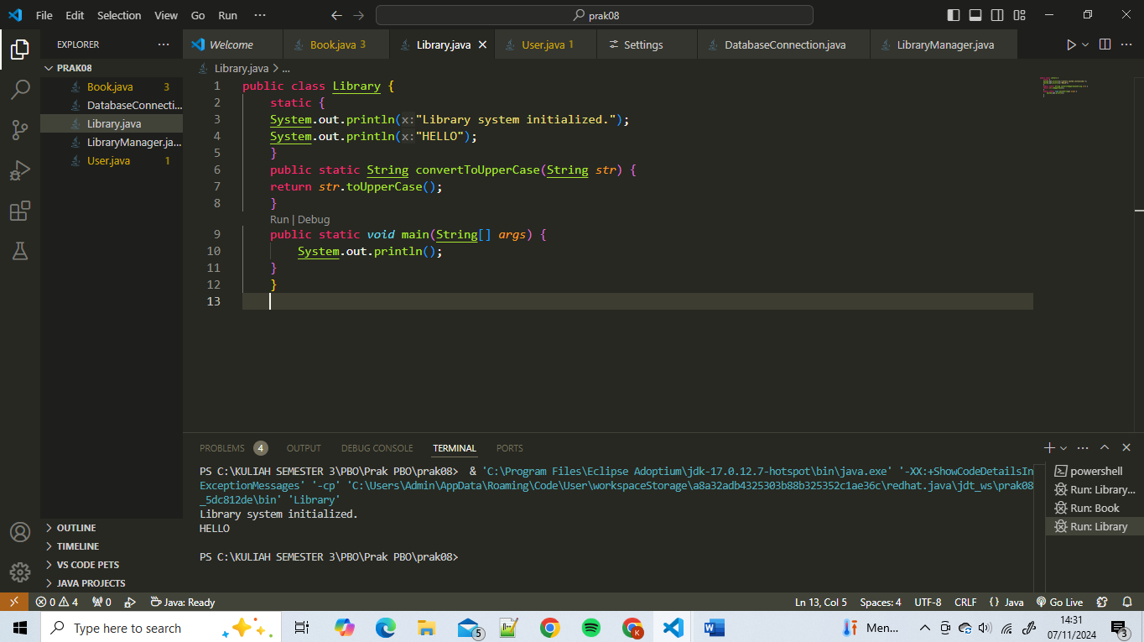

User.java

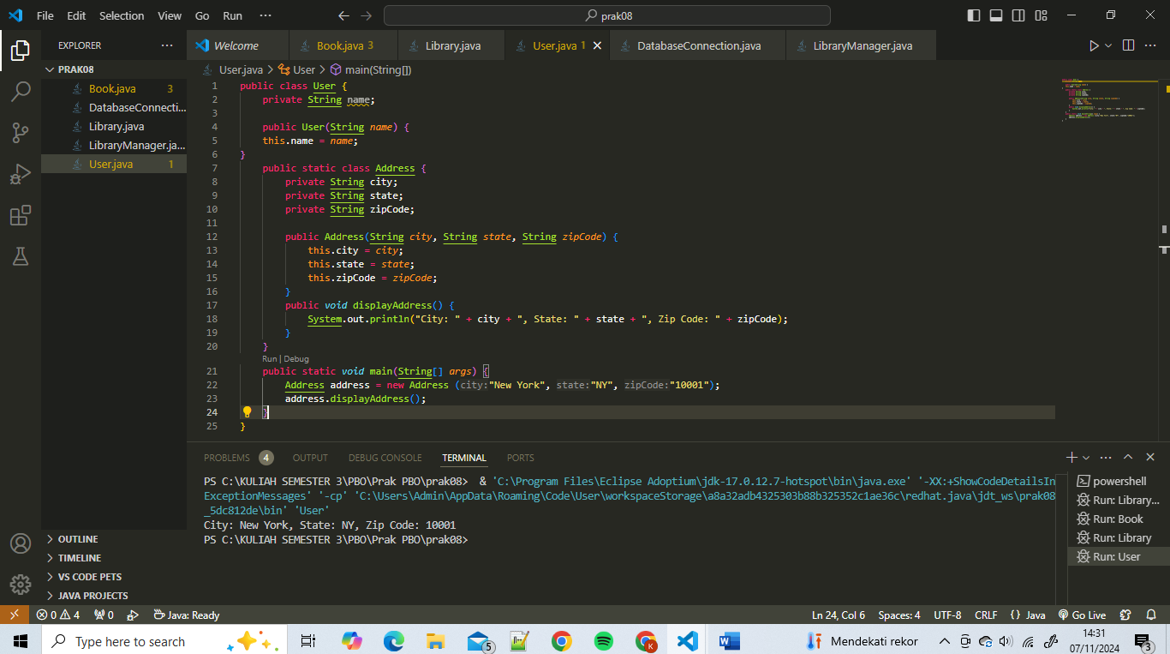

DatabaseConnection.java

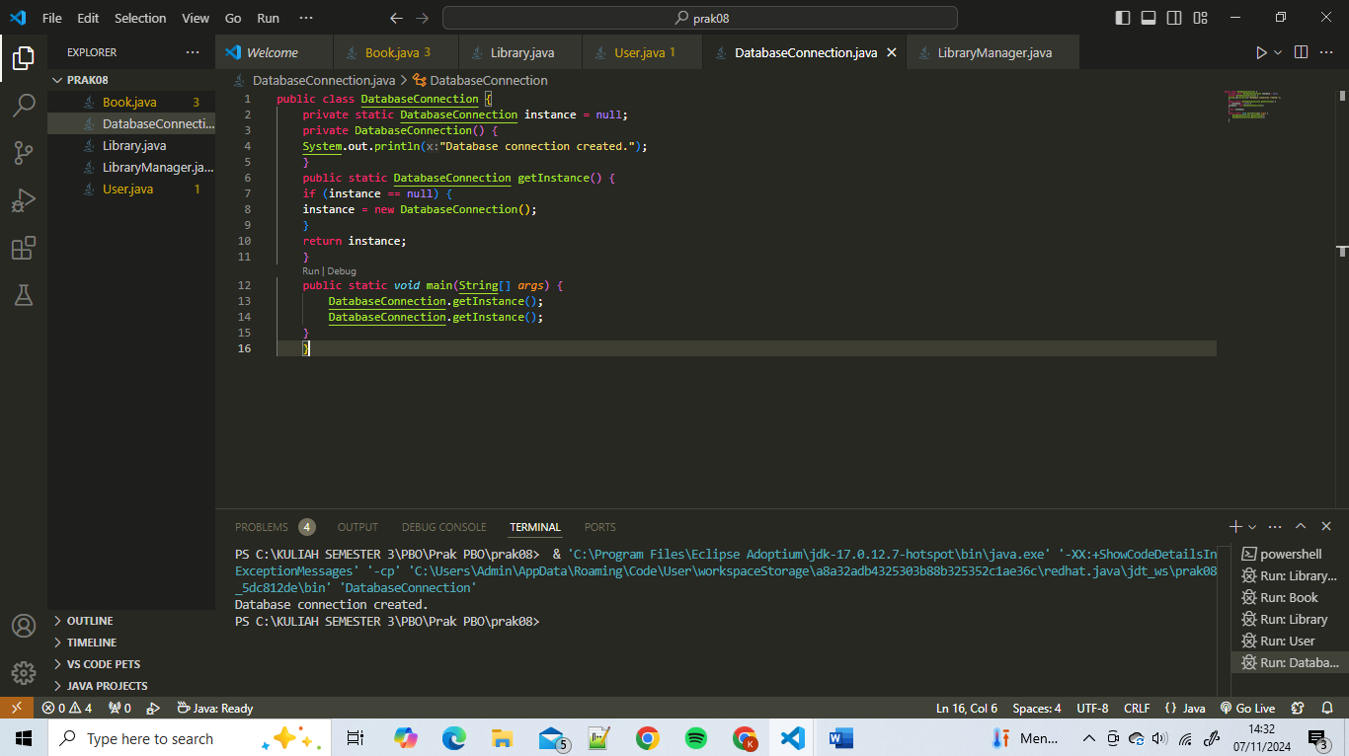

LibraryManager.java

